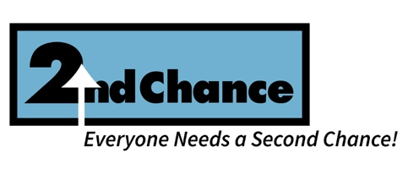
Job Title: Director of Donor and Community Relations
Reports To: Chief Executive Officer (CEO)
Location: Fort Lauderdale, FL
Status: Full-Time, Exempt

Organizational Overview
Second Chance Society, Inc. (SCS) exists to give motivated individuals the opportunity to lift themselves out of poverty and achieve economic self-sufficiency. We do this through direct support services, workforce development, and strategic partnerships that serve ALICE (Asset-Limited, Income-Constrained, Employed) and formerly incarcerated populations in Broward County.

Position Summary
The Director of Donor and Community Relations is a mission-driven leader responsible for cultivating and stewarding relationships with donors, funders, community partners, and the broader public. This position leads fundraising campaigns, donor communications, and public engagement strategies that enhance SCS’s visibility, credibility, and revenue. The Director works closely with the CEO and Development Consultant to meet annual fundraising goals and grow a culture of philanthropy.

Key Responsibilities
Donor Relations & Fund Development
- Manage donor database (CRM), tracking contributions, acknowledgments, and engagement
- Implement and grow an annual giving strategy, including major gifts and monthly donors
- Create donor communication pieces, impact reports, and stewardship touchpoints
- Assist with grant proposal development, reporting, and funder follow-up
- Support CEO and Development Consultant with donor cultivation and sponsorship asks

Community Engagement & Public Relations
- Develop and manage community partnerships and collaborative events
- Represent SCS at community meetings, nonprofit networks, and speaking engagements
- Coordinate volunteer engagement strategies and service opportunities
- Build and maintain strong relationships with local businesses, civic groups, and media

Marketing & Communications
- Lead the production of newsletters, social media content, press releases, and website updates
- Design and manage outreach materials, annual impact report, and branding assets
- Support the planning and promotion of fundraising events and campaigns

Qualifications
- Bachelor’s degree in nonprofit management, communications, public relations, or related field (Master’s preferred)
- Minimum 3 years of experience in fundraising, donor relations, or community engagement
- Strong written and verbal communication skills; persuasive and clear communicator
- Familiarity with donor databases (preferably DonorPerfect, or similar)
- Experience planning donor or community events
- Self-starter with ability to manage multiple projects independently

